Lambda Function

Step 1: Create two S3 bucket. One with data and another with no data (empty bucket)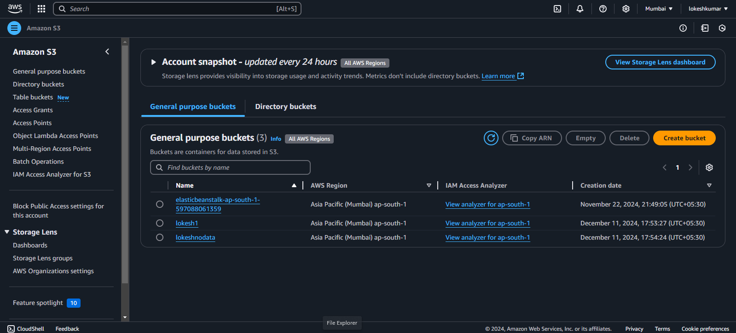

Step 2: Create a function in Lambda and give a name.

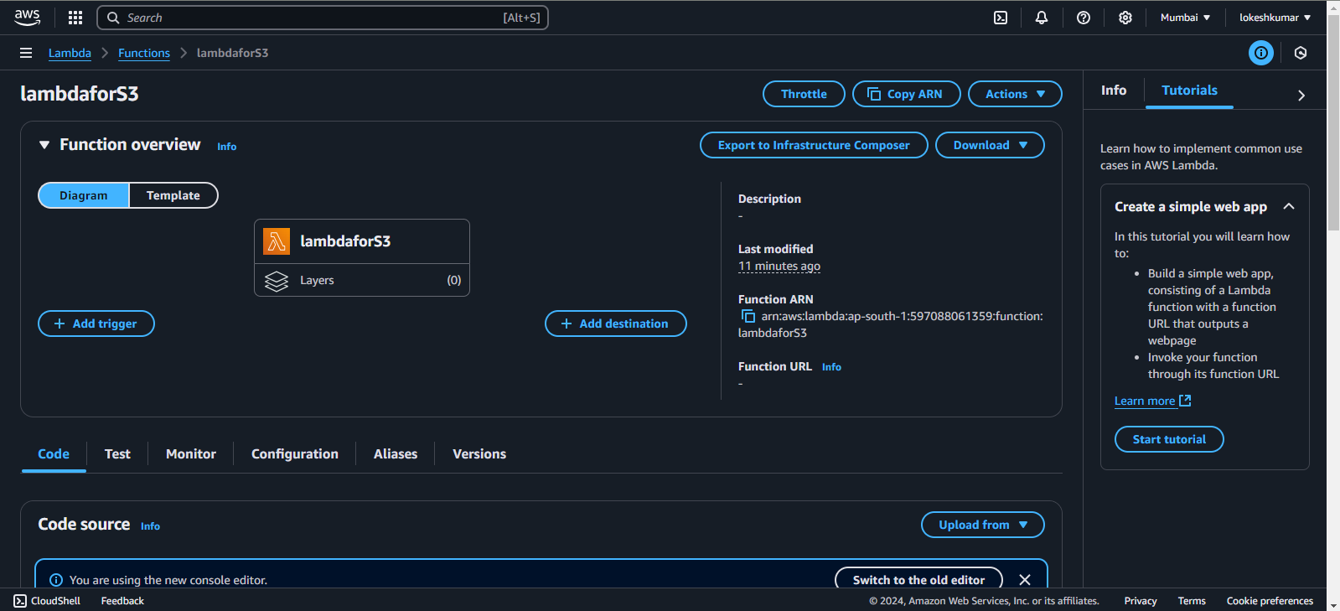

Step 3: Create a Test Event. Deploy and Test your code using Test Event

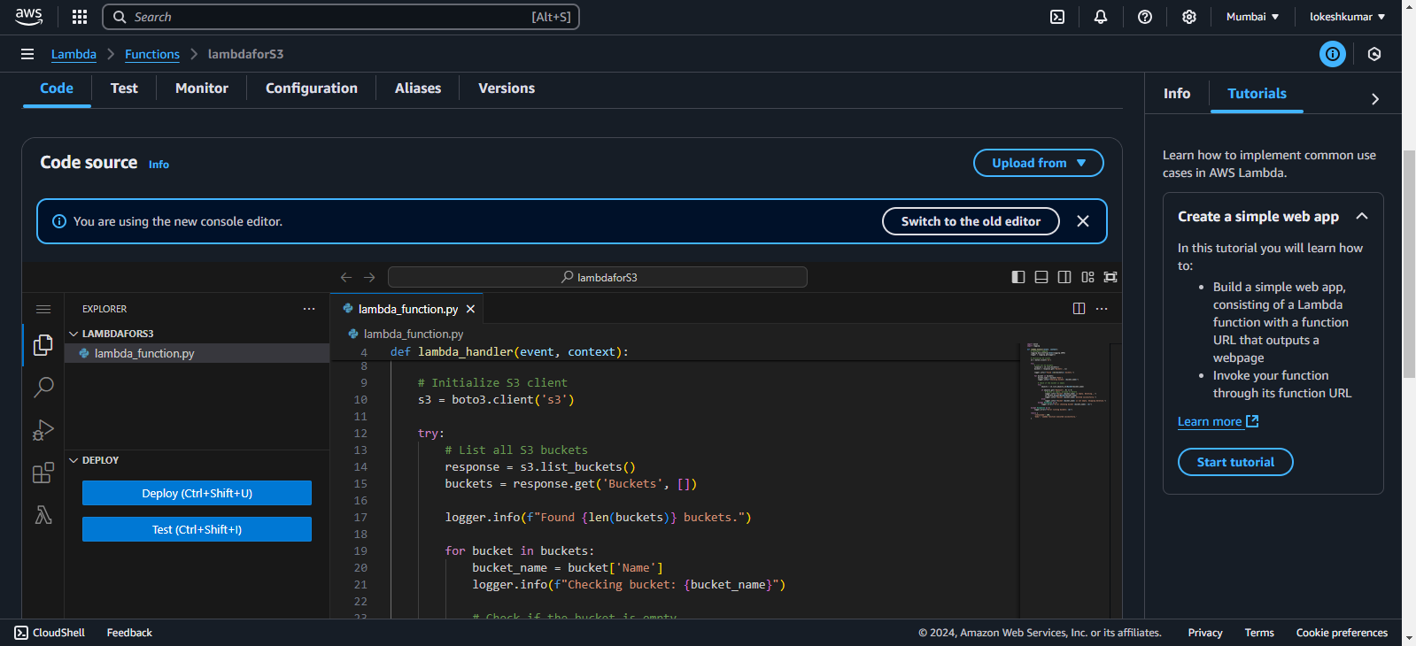

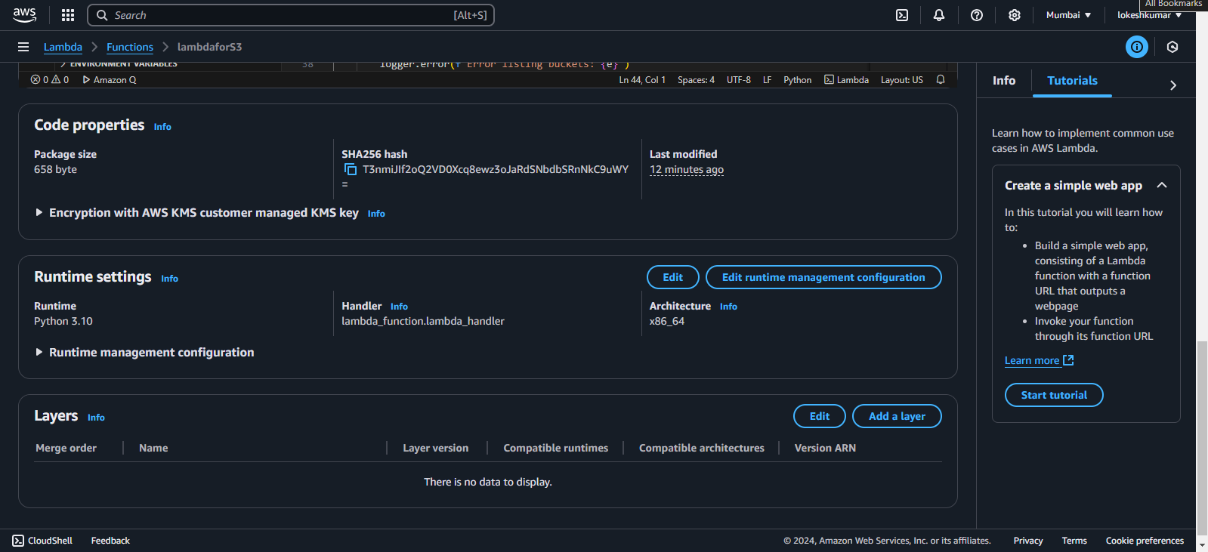

Step 4: Give limited permissions to the IAM user to execute the code using inline policy in rules.

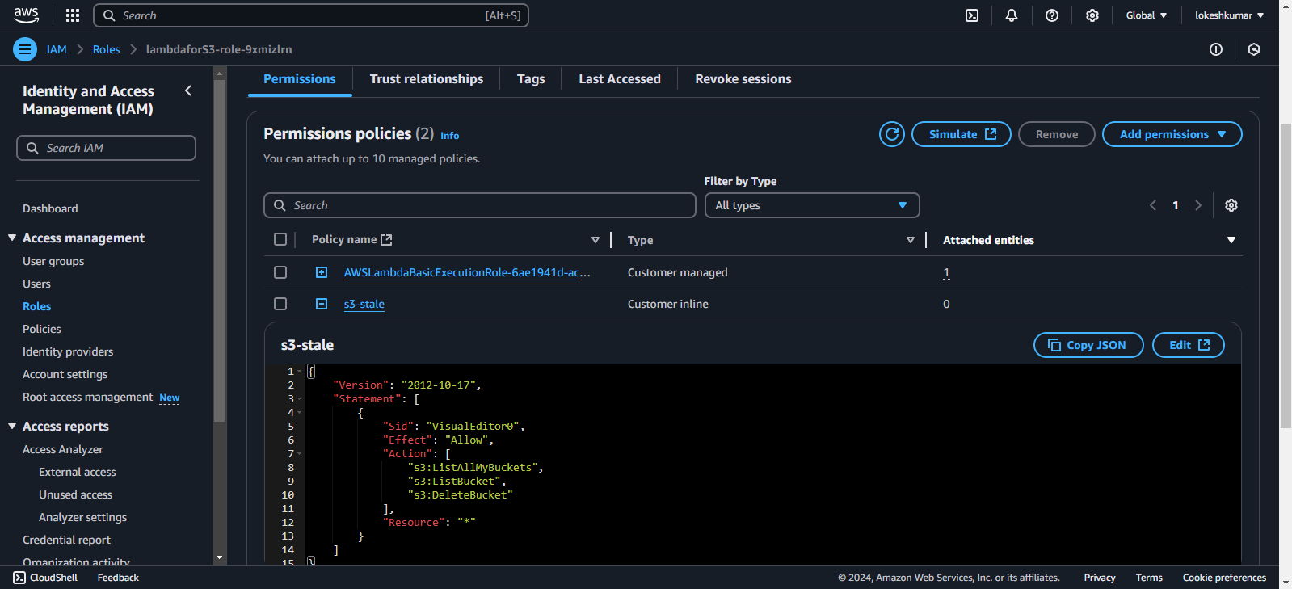

Step 5: After giving limited permissions and test the code using test event so that it can execute the code.

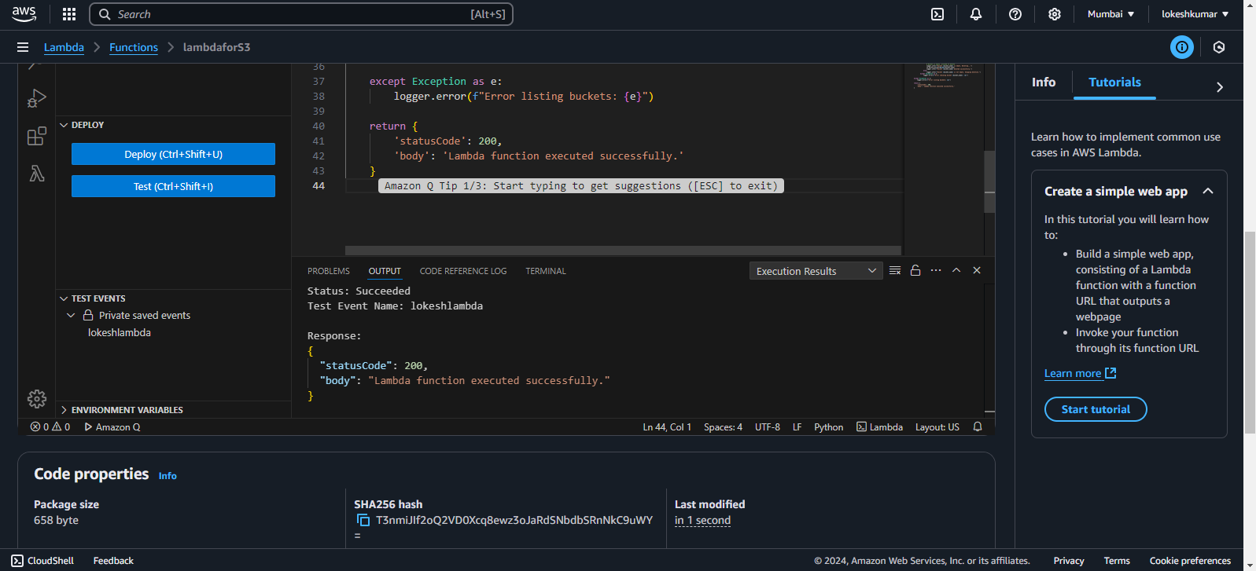

Output:

